Question 1:
Testing the program for finding the inverses of elements in Z_{p}:
The screen-dump in the appendix gives a print of the array storing the inverses of all units of Z₁₃. All results easily verifiable mentally.

Modification:
I could halve the number of steps required by adding some code to initially set all elements of x[100] to zero. Next, if the inverse of the element n (n⁻¹) is input to x[n-1] in the array, then x[n⁻¹ -1] is given the value of n if x[n⁻¹ -1] is initially zero.

Question 2:
I estimate the procedure to be of complexity Ө(p²).

Question 3:
In the appendix, I have manually calculated this projects’ definition of the echelon form of a matrix which has also been calculated via my program. As you can see in the appendix, they agree.

The echelon forms of the given matrices are:

For A₁ in mod 11: For A₂ in mod 37:
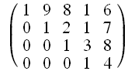
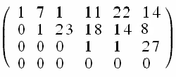

Hence, A₁’s row space is 4, and A₂’s row space is 3.

Bases for their row spaces are simply the row vectors, since by definition, these span the required space, and due to their echelon form (namely the criterion that ‘l(1) < l(2) <…< l(r)’), the rows are linearly independent, hence form a basis. Therefore a set of basis vectors are:
For A₁’s row space: { (1,9,8,1,6)^{T}, (0,1,2,1,7)^{T} , (0,0,1,3,8)^{T} , (0,0,0,1,4)^{T} }
For A₂’s row space: { (1,7,1,11,22,14)^{T} , (0,1,23,18,14,6)^{T} , (0,0,0,1,1,27)^{T} }

Question 4:

The kernels for the matrices B₁ and B₂ can be expressed by the bases:

For B₁: { (3,2,3,1,1)^{T}}
For B₂: { (36,26,34,11,1,0)^{T} , (28,7,14,26,0,1)^{T} }

Some test data used was that of three different matrices, screen prints of the calculated kernel bases and my check of these are in the appendix. The only detail I need to expand on here was that the matrices used are already in echelon form, which does not lose any generality, as evident from my program in answer to question 3.
The coded algorithm can be briefly described as thus. Given a matrix, after reducing to echelon form, first it counts the number of zeroes before the first one in each column, then for each row, it removes any degeneracy (by which I mean, if there is a row with a one and then just zeroes, then this row is set as zero, and also the column the one is in) and this row is marked. Then it takes away all rows below the current top row, after the entire row is multiplied by the value at the current top row, in the same column as the first one (looking from left to right). This is equivalent to substituting in equations as would be done in a ‘Gaussian Elimination’ fashion to solve the equation Ax=0, where A is this matrix, and x is by definition in ker A. Finally, a simple ‘for’ loop translates this matrix containing all information about components of kernel vectors to a matrix where each column is a basis vector, and the rows are the components (just a simple way of storing the basis in an array). Note that if a row was not marked earlier on in the degeneracy stage and the whole row was zero then at the last stage, the element in this row in the same column as the row is set as 1 (equivalent to saying this component is arbitrary in kernel calculations). Finally, it only prints the columns of the final matrix which aren’t uniformly zero, and counts how many aren’t – this is the nullity of the given matrix.

Question 5:

For a subspace U ⊆ F^{n}, then:

dim U + dim U° = dim F^{n} = n.

Question 6:

Since the kernel of A₂ is U°, if we take the row space of A₂ as U, we find that U° can be spanned by the basis vectors:
e₁ = (1,7,1,11,22,14)^{T}, e₂ = (0,1,23,18,14,8)^{T}, e₃ = (0,0,0,1,1,27)^{T};
Then, taking a matrix A₂° as the 3 x 6 matrix with rows vectors as the above basis vectors for U°, hence, its row space is U°. The kernel of A₂° is found to be spanned by the basis vectors:
f₁ = (0,28,15,1,0,0)^{T}, f₂ = (7,31,0,0,1,0)^{T}, f₃ = (34,17,20,0,0,1)^{T};
Noting then that:
e₁ = 11f₁ + 22f₂ + 14f₃,
e₂ = 18f₁ + 14f₂ + 8f₃,
e₃ = f₁ + f₂ + 27f₃;
Hence, {e₁,e₂,e₃} is contained in (U°)° (the kernel of A₂°), by the definition of the kernel as a subspace of F^{n}. Ergo, since this is a basis, and it is also the basis of U, then we have verified that (U°)° = U.

Question 7:

My program is highly derivative of the previous two algorithms. To find a basis for U and W, described by the given matrices’ row spaces (with equal number of columns), it just transforms them to echelon form. This process performs legal operations on the spanning set of row vectors to make them linearly independent. Then, it creates another matrix over the same vector space, of dimension the same as the number of columns as for A and B, and rows in excess of the sum of number of rows of A’s plus B’s. Then it transforms this matrix to echelon form. This gives a basis for U + W in the same way as before since the set of all row vectors from A and B must span U + W. Then, it finds bases for U° and W°, by using the program from the last question to find bases for kernels of A and B. Then in a similar way to before, it locates a basis for U° + W°, by transforming to echelon form. Then, logically, since:

As U and W are subspaces of a vector space:

(U°)° = U and U° + W° = (U ∩ W)° => (U° + W°)° = U ∩ W;

then that implies that the kernel of this previous matrix has basis the same as U ∩ W. Also, the program counts the dimension of U,W, U + W and U ∩ W. A relation between these dimensions is that:

dim(U + W) = dim U + dim W – dim(U ∩ W).

For the matrices A₁ and B₁, with row spaces U₁ and W₁ respectively:

U₁ = span{ (1,9,8,1,6)^{T} , (0,1,2,1,7)^{T} , (0,0,1,3,8)^{T} , (0,0,0,1,4)^{T} }, dim U₁ = 4;
W₁= span{ (1,5,7,9,1)^{T} , (0,1,0,6,3)^{T} , (0,0,1,7,1)^{T} , (0,0,0,1,10)^{T}}, dim W₁ = 4;
U₁ + W₁= span{ (1,9,8,1,6)^{T} , (0,1,2,1,7)^{T} , (0,0,1,3,8)^{T} , (0,0,0,1,0)^{T} , (0,0,0,0,1)^{T}}, dimU₁ + W₁ = 5 (i.e. U₁ + W₁ = Z₁₁⁵);
U₁∩W₁= span{ (4,9,1,0,0)^{T} , (7,0,0,1,0)^{T} , (1,9,0,0,1)^{T} }, dimU₁∩W₁ = 3.

For the matrices A₂ and B₂, with row spaces U₂ and W₂ respectively:

U₂ = span{ (1,7,1,11,22,14)^{T} , (0,1,23,18,14,8)^{T} , (0,0,0,1,1,27)^{T} }, dim U₂ = 3;
W₂= span{ (1,3,0,4,27,32)^{T} , (0,1,22,13,8,13)^{T} , (0,0,1,22,20,6)^{T} , (0,0,0,1,26,11)^{T}}, dim W₂ = 4;
U₂ + W₂= span{ (1,7,1,11,22,14)^{T} , (0,1,23,18,14,8)^{T} , (0,0,1,6,21,16)^{T} , (0,0,0,1,15,21)^{T} , (0,0,0,0,1,26)^{T}}, dimU₂ + W₂ = 5;
U₂∩W₂= span{ (7,8,26,19,1,0)^{T} , (34,2,8,14,0,1)^{T} }, dimU₂∩W₂ = 2.

For the matrix A₃ with row space U₃ and the kernel space U₃°:

U₃ = span{ (1,0,0,0,1,0,0)^{T} , (0,1,0,0,3,3,2)^{T} , (0,0,1,0,6,0,0)^{T} , (0,0,0,1,5,2,4)^{T} }, dim U₃ = 4;
U₃° = span{ (1,3,6,5,6,0,0)^{T} , (0,1,0,3,0,2,0)^{T} , (0,0,0,1,0,2,4)^{T} }, dim U₃° = 3;
U₃ + U₃° = span{ (1,0,0,0,1,0,0)^{T} , (0,1,0,0,3,3,2)^{T} , (0,0,1,2,4,2,0)^{T} , (0,0,0,1,6,3,3)^{T} , (0,0,0,0,1,6,6)^{T} , (0,0,0,0,0,1,1)^{T} }, dimU₃ + U₃° = 6;
U₃∩U₃° = span{ (0,1,0,5,0,6,1)^{T} }, dimU₃∩U₃° = 1.
[Let v be the last basis vector.]

Question 8:

In a vector space over R, with the usual scalar product ( ∙ ,the equivalent to matrix multiplication of a 1 x n matrix with a n x 1 matrix), we cannot form a subspace that contains elements orthogonal (nil scalar product) to all other elements of the subspace, omitting the zero vector of course. Ergo, for any subspace, U, U∩U°=Ø. However, in the third example v∙v = 0, and for all x in U₃, x∙v = 0. Finally, note that v is in U₃ as is equal to U₃’s first basis vector plus five lots of the last. So, U₃∩U₃°≠ Ø!

Appendix: Question 1: Output 1.1:
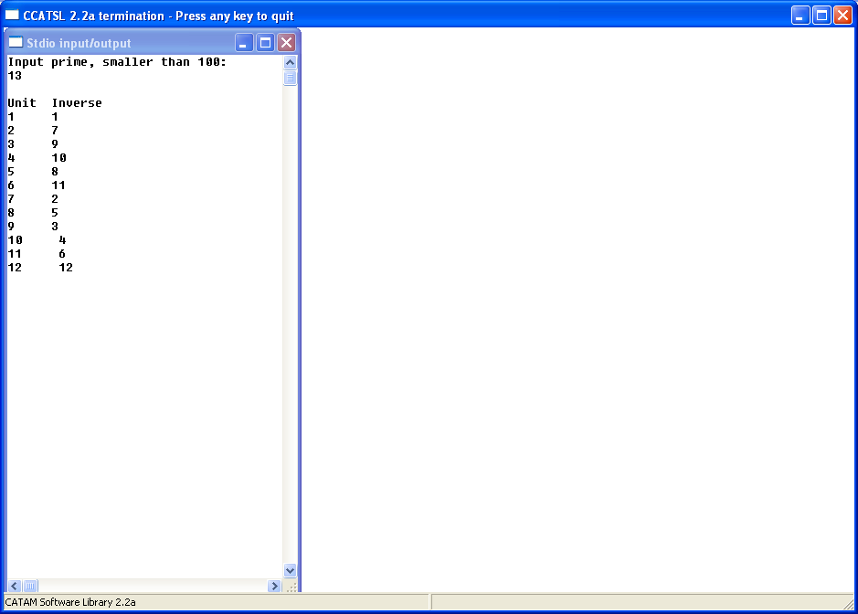
Question 3: Output 3.1: (In mod 13)
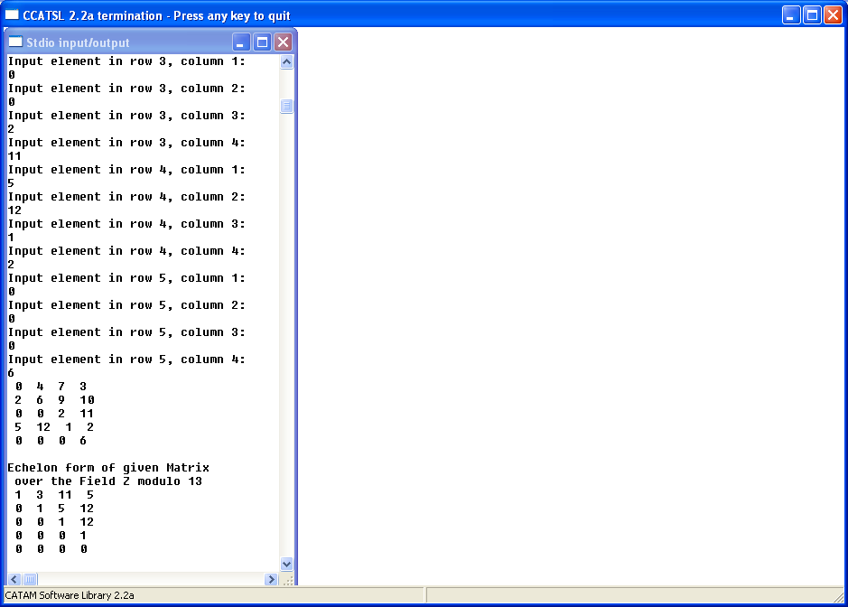
Question 4: Bases for test matrices: (All in mod 7) Output 4.1:
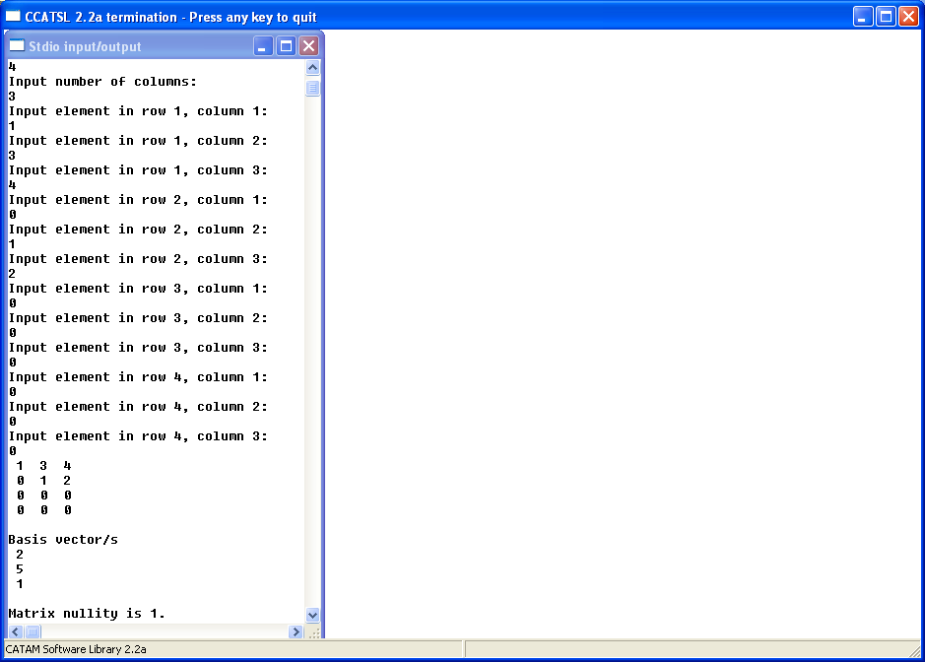
Output4.2: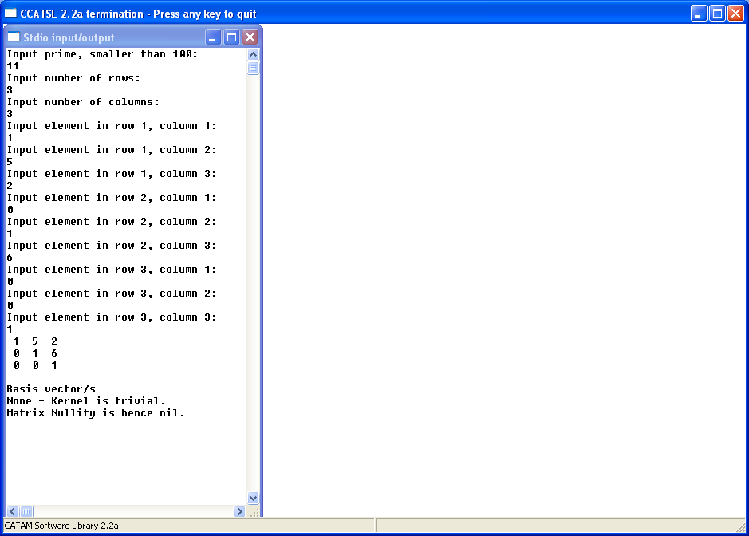

Output 4.3:
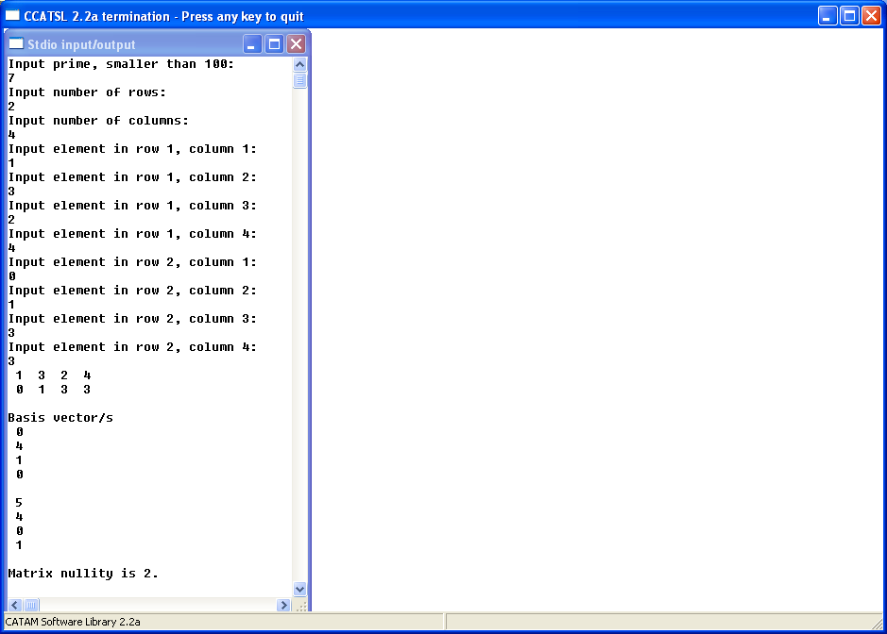

Program Listing:
1_2Inversion.c – Program for Question 1. Finds inverses of elements of Z_{p.}
1_2Echelon.c – Program for Question 3. Converts to Echelon form.
1_2KernelSpace.c – Program for Question 4. Finds kernel of given matrix.
1_2SubspaceBases.c – Program for Question 7. Finds bases for subspaces.

1_2Inversion.c:

#include <catam.h>
int i,j,p,x[100];

int Inv(int iv,int jv,int pv) {int m;
m = iv*jv%pv;
return m;}

int MainCL(void) {
printf("Input prime, smaller than 100:\n");
fflush(stdout);
scanf("%i",&p);

for (i=1;i<p;i++) {
for (j=1;j<p;j++) {
int n;
n = Inv(i,j,p);
if (abs(n-1)<0.5) {x[i-1] = j;}
}
}
printf("\nUnit Inverse\n");
for (i=1;i<p;i++) {printf("%i %i\n",i,x[i-1]);}
return 0;}

1_2Echelon.c:

#include <catam.h>

double tiny=5e-20;
int p,i,j,k,l,I,J,r,c,m,n;
int x[100],X[10][10],TX[10][10];
int Inv(int iv,int jv,int pv) {int m;
m = iv*jv%pv;
return m;}

int MainCL(void) {

printf("Input prime, smaller than 100:\n");
fflush(stdout);
scanf("%i",&p);

for (i=1;i<p;i++) {
for (j=1;j<p;j++) {
int n;
n = Inv(i,j,p);
if (abs(n-1)<tiny) {x[i-1] = j;}
}
}

/*---Main---*/

printf("Input number of rows:\n");
fflush(stdout);
scanf("%i",&r);
printf("Input number of columns:\n");
fflush(stdout);
scanf("%i",&c);

for (m=0;m<r;m++) {
for (n=0;n<c;n++) {
int k;
printf("Input element in row %i, column %i:\n",m+1,n+1);
fflush(stdout);
scanf("%i",&k);
X[m][n]=k%p;
}
}

/*---Initial Output---*/

for (m=0;m<r;m++) {
for (n=0;n<c;n++) {
if (abs(n-c+1)<tiny) {printf(" %i \n",X[m][n]);}
else {printf(" %i ",X[m][n]);}
}
}

for (I=0;I<r;I++) {
for (J=I;J<r;J++) {

double Ti[10],yoo[10];
int T[10],Tf[10],Tx[10],yo[10];

for (i=0;i<r;i++) {
T[i]=0;
Ti[i]=0;
Tx[10];
yoo[i]=0;
Tf[i]=0;
yo[i]=0;}

for (i=0;i<r;i++) {
int Xsumi;
Xsumi = 0;
for (j=0;j<c;j++) {if (X[i][j] <0.5) {Xsumi = Xsumi + 1;}
else {j=c;}
}
T[i] = Xsumi;
}

for (i=0;i<r;i++) {Ti[i]=T[i]+i*(0.01);}

for (i=0;i<r;i++) {
int ord;
ord=0;
for (j=0;j<r;j++) {
if (Ti[j]-Ti[i]<tiny) {ord=ord+1;} }
yo[i] = ord-1; }

for (i=0;i<r;i++) {
int y;
y=0;
y=yo[i];
yoo[y]=Ti[i]; }

for (i=0;i<r;i++) {
for (j=0;j<r;j++) {
double m;
int n;
m=0;
n=0;
m=yoo[i]-j;
n=rint(100*m);
if (abs(m)<1) {yo[i]=n;j=r;}
}
}

for (i=0;i<r;i++) {
int y;
y=0;
y=yo[i];
Tf[y]=i;}

for (i=0;i<r;i++) {
int T;
T=Tf[i];
for (j=0;j<c;j++) {
TX[T][j]=X[i][j];} }

for (i=0;i<r;i++) {
int Xsumi;
Xsumi = 0;
for (j=0;j<c;j++) {if (TX[i][j] <0.5) {Xsumi = Xsumi + 1;}
else {j=c;} }
Tx[i] = Xsumi;
}

for (i=J;i<r;i++) {
int l,in,li;
l=0;
in=0;
li=0;
in=Tx[i];
l=TX[i][in];
li=x[l-1];
if (in-c<tiny) {for (j=0;j<c;j++) {TX[i][j]=li*TX[i][j]%p;}
}
}

if (Tx[J]!=c)
{for (i=J+1;i<r;i++) {
if (abs(Tx[i]-Tx[J])<tiny) {
for (j=0;j<c;j++) {
TX[i][j]=(TX[i][j]-TX[J][j]+p)%p;
}
}
}
}

for (i=0;i<r;i++) {
for (j=0;j<c;j++) {
X[i][j]=TX[i][j];
}
}

}
}

/*---Final Output---*/

printf("\nEchelon form of given Matrix\n over the Field Z modulo %i\n",p);
for (m=0;m<r;m++) {
for (n=0;n<c;n++) {
if (abs(n-c+1)<tiny) {printf(" %i \n",X[m][n]);}
else {printf(" %i ",X[m][n]);}
}
}

return 0;}

1_2KernelSpace.c:

#include <catam.h>

double tiny=5e-20;
int p,i,j,k,t,l,q,I,J,r,c,m,n,ker;
int x[100],X[10][10],Y[10][10],Xd[10][10],TX[10][10],K[10][10],L[10],S[10],T[10],U[10];
int Inv(int iv,int jv,int pv) {int m;
m = iv*jv%pv;
return m;}
int MainCL(void) {
ker=0;
printf("Input prime, smaller than 100:\n");
fflush(stdout);
scanf("%i",&p);

for (i=1;i<p;i++) {
for (j=1;j<p;j++) {
int n;
n = Inv(i,j,p);
if (abs(n-1)<tiny) {x[i-1] = j;}
}
}

printf("Input number of rows:\n");
fflush(stdout);
scanf("%i",&r);
printf("Input number of columns:\n");
fflush(stdout);
scanf("%i",&c);

for (m=0;m<r;m++) {
for (n=0;n<c;n++) {
int k;
printf("Input element in row %i, column %i:\n",m+1,n+1);
fflush(stdout);
scanf("%i",&k);
X[m][n]=k%p;
Xd[m][n]=k&p;
K[m][n]=0;
}
}

/*---Initial Output---*/

for (m=0;m<r;m++) {
for (n=0;n<c;n++) {
if (abs(n-c+1)<tiny) {printf(" %i \n",X[m][n]);}
else {printf(" %i ",X[m][n]);}
}
}

/*---Echeloning---*/

for (I=0;I<r;I++) {
for (J=I;J<r;J++) {

double Ti[10],yoo[10];
int T[10],Tf[10],Tx[10],yo[10];

for (i=0;i<r;i++) {
T[i]=0;
Ti[i]=0;
Tx[10];
yoo[i]=0;
Tf[i]=0;
yo[i]=0;}

for (i=0;i<r;i++) {
int Xsumi;
Xsumi = 0;
for (j=0;j<c;j++) {if (X[i][j] <0.5) {Xsumi = Xsumi + 1;}
else {j=c;}
}
T[i] = Xsumi;
}

for (i=0;i<r;i++) {Ti[i]=T[i]+i*(0.01);}

for (i=0;i<r;i++) {
int ord;
ord=0;
for (j=0;j<r;j++) {
if (Ti[j]-Ti[i]<tiny) {ord=ord+1;} }
yo[i] = ord-1; }

for (i=0;i<r;i++) {
int y;
y=0;
y=yo[i];
yoo[y]=Ti[i]; }

for (i=0;i<r;i++) {
for (j=0;j<r;j++) {
double m;
int n;
m=0;
n=0;
m=yoo[i]-j;
n=rint(100*m);
if (abs(m)<1) {yo[i]=n;j=r;}
}
}

for (i=0;i<r;i++) {
int y;
y=0;
y=yo[i];
Tf[y]=i;}

for (i=0;i<r;i++) {
int V;
V=Tf[i];
for (j=0;j<c;j++) {
TX[V][j]=X[i][j];} }

for (i=0;i<r;i++) {
int Xsumi;
Xsumi = 0;
for (j=0;j<c;j++) {if (TX[i][j] <0.5) {Xsumi = Xsumi + 1;}
else {j=c;} }
Tx[i] = Xsumi;
}

for (i=J;i<r;i++) {
int l,in,li;
l=0;
in=0;
li=0;
in=Tx[i];
l=TX[i][in];
li=x[l-1];
if (in-c<tiny) {for (j=0;j<c;j++) {TX[i][j]=li*TX[i][j]%p;}
}
}

if (abs(Tx[J]-c)>0.5)
{for (i=J+1;i<r;i++) {
if (abs(Tx[i]-Tx[J])<tiny) {
for (j=0;j<c;j++) {
TX[i][j]=(TX[i][j]-TX[J][j]+p)%p;
}
}
}
}

for (i=0;i<r;i++) {
for (j=0;j<c;j++) {
X[i][j]=TX[i][j];
}
}

}
}

for (i=0;i<r;i++) {
for (j=0;j<c;j++) {
Xd[i][j]=X[i][j];
}
}

/*---Basis Location---*/

for (i=0;i<r;i++) {
int Xsumi;
Xsumi = 0;
for (j=0;j<c;j++) {if (X[i][j] <0.5) {Xsumi = Xsumi + 1;}
else {j=c;}
}
S[i] = Xsumi;
}

for (i=0;i<r;i++) {
/*Removing current degeneracy*/
for (m=1;m<c+1;m++) {
int s,g;
for (k=0;k<r;k++) {
int Ysumi;
Ysumi = 0;
for (j=0;j<c;j++) {if (Xd[k][j] <0.5) {Ysumi = Ysumi + 1;}
}
U[k] = Ysumi;
}
for (j=0;j<r;j++) {
g=S[r-1-j];
if (abs(U[r-1-j]-c+1)<tiny) {for (k=0;k<c;k++)
{Xd[r-1-j][k]=0;
Xd[k][g]=0;}
L[g]=1;}
}
}
for (j=i+1;j<r;j++) {
int a;
a=Xd[i][S[j]];
for (k=0;k<c;k++) {
int t;
t=S[j];
Y[j][k]=Xd[j][k]*a;
Xd[i][k]=(Xd[i][k]-Y[j][k]+p)%p;
Y[j][k]=0;
}
}
}

for (i=0;i<r;i++) {
if (abs(S[i]-c)>tiny) {
for (j=S[i]+1;j<c;j++) {
K[S[i]][j]=(p-Xd[i][j])%p;
}
}
}

for (i=0;i<11;i++) {
int Xsumi;
Xsumi = 0;
S[i]=c;
for (j=0;j<c;j++) {if (K[i][j] <0.5) {Xsumi = Xsumi + 1;}
else {j=c;}
}
S[i] = Xsumi;
}

for (i=0;i<c;i++) {
if (abs(L[i]-1)>tiny) {if (abs(S[i]-c)<tiny) {K[i][i]=1;}}
}

for (i=0;i<c;i++) {
int Xsumi;
Xsumi = 0;
for (j=0;j<c;j++) {if (K[j][i] <0.5) {Xsumi = Xsumi + 1;}
else {j=c;}
}
S[i] = Xsumi;
}

/*Basis Output*/

printf("\nBasis vector/s\n");

for (i=0;i<c;i++) {
if (abs(S[i]-c)>tiny) {
ker = ker + 1;
for (j=0;j<c;j++) {
if (abs(j-c+1)<tiny) {printf(" %i \n\n",K[j][i]);}
else {printf(" %i \n",K[j][i]);}
}
}
}

if (abs(ker)<tiny) {printf("None - Kernel is trivial.\nMatrix Nullity is hence nil.");}
else printf("Matrix nullity is %i.",ker);

return 0;}

1_2SubspaceBases.c:

#include <catam.h>

double tiny=5e-20;
int p,i,j,k,t,l,q,I,J,ra,rb,ca,cb,m,n;
int ranka,rankb,rankab,rankanb;
int x[100];
int Xa[10][10],Ya[10][10],Xda[10][10],TXa[10][10],Ka[10][10],KTa[10][10],La[10],Sa[10],Ta[10],Ua[10];
int Xb[10][10],Yb[10][10],Xdb[10][10],TXb[10][10],Kb[10][10],KTb[10][10],Lb[10],Sb[10],Tb[10],Ub[10];
int Sum[20][10],TSum[20][10],Sumo[20][10],TXs[20][10],Ks[20][10],Ls[20],Ss[20],Ts[20],Us[20];
int Sumod[20][10],Ys[20][10];
int Inv(int iv,int jv,int pv) {int m;
m = iv*jv%pv;
return m;}
int MainCL(void) {
ranka=0;
rankb=0;
rankab=0;
rankanb=0;

printf("Input prime, smaller than 100:\n");
fflush(stdout);
scanf("%i",&p);

for (i=1;i<p;i++) {
for (j=1;j<p;j++) {
int n;
n = Inv(i,j,p);
if (abs(n-1)<tiny) {x[i-1] = j;}
}
}
printf("Input common number of columns of \nmatrices A and B:\n");
fflush(stdout);
scanf("%i",&ca);
printf("Input number of rows of matrix A:\n");
fflush(stdout);
scanf("%i",&ra);
printf("Input number of rows of matrix B:\n");
fflush(stdout);
scanf("%i",&rb);
cb=ca;

printf("Let the row space of A be U,of B be W,\nthe space of their intersection, UnW,\nand the space of their sum be U+W");

printf("\n\nFor matrix A\n");
for (m=0;m<ra;m++) {
for (n=0;n<ca;n++) {
int k;
printf("Input element in row %i, column %i:\n",m+1,n+1);
fflush(stdout);
scanf("%i",&k);
Xa[m][n]=k%p;
Xda[m][n]=k&p;
Ka[m][n]=0;
}
}

printf("\n\nFor matrix B\n");
for (m=0;m<rb;m++) {
for (n=0;n<cb;n++) {
int k;
printf("Input element in row %i, column %i:\n",m+1,n+1);
fflush(stdout);
scanf("%i",&k);
Xb[m][n]=k%p;
Xdb[m][n]=k&p;
Kb[m][n]=0;
}
}

for (m=0;m<10;m++) {
for (n=0;n<10;n++) {
Sum[m][n]=Xa[m][n];
}
}

for (m=10;m<20;m++) {
for (n=0;n<10;n++) {
Sum[m][n]=Xb[m-10][n];
}
}

/*---Initial Output---*/

printf("\nMatrix A:\n\n");
for (m=0;m<ra;m++) {
for (n=0;n<ca;n++) {
if (abs(n-ca+1)<tiny) {printf(" %i \n",Xa[m][n]);}
else {printf(" %i ",Xa[m][n]);}
}
}

printf("\nMatrix B:\n\n");
for (m=0;m<rb;m++) {
for (n=0;n<cb;n++) {
if (abs(n-cb+1)<tiny) {printf(" %i \n",Xb[m][n]);}
else {printf(" %i ",Xb[m][n]);}
}
}

/*------------------------------------A--------------------------------------*/

/*---Echeloning A---*/

for (I=0;I<ra;I++) {
for (J=I;J<ra;J++) {

double Ti[10],yoo[10];
int T[10],Tf[10],Tx[10],yo[10];

for (i=0;i<ra;i++) {
T[i]=0;
Ti[i]=0;
Tx[10];
yoo[i]=0;
Tf[i]=0;
yo[i]=0;}

for (i=0;i<ra;i++) {
int Xsumi;
Xsumi = 0;
for (j=0;j<ca;j++) {if (Xa[i][j] <0.5) {Xsumi = Xsumi + 1;}
else {j=ca;}
}
T[i] = Xsumi;
}

for (i=0;i<ra;i++) {Ti[i]=T[i]+i*(0.01);}

for (i=0;i<ra;i++) {
int ord;
ord=0;
for (j=0;j<ra;j++) {
if (Ti[j]-Ti[i]<tiny) {ord=ord+1;} }
yo[i] = ord-1; }

for (i=0;i<ra;i++) {
int y;
y=0;
y=yo[i];
yoo[y]=Ti[i]; }

for (i=0;i<ra;i++) {
for (j=0;j<ra;j++) {
double m;
int n;
m=0;
n=0;
m=yoo[i]-j;
n=rint(100*m);
if (abs(m)<1) {yo[i]=n;j=ra;}
}
}

for (i=0;i<ra;i++) {
int y;
y=0;
y=yo[i];
Tf[y]=i;}

for (i=0;i<ra;i++) {
int V;
V=Tf[i];
for (j=0;j<ca;j++) {
TXa[V][j]=Xa[i][j];} }

for (i=0;i<ra;i++) {
int Xsumi;
Xsumi = 0;
for (j=0;j<ca;j++) {if (TXa[i][j] <0.5) {Xsumi = Xsumi + 1;}
else {j=ca;} }
Tx[i] = Xsumi;
}

for (i=J;i<ra;i++) {
int l,in,li;
l=0;
in=0;
li=0;
in=Tx[i];
l=TXa[i][in];
li=x[l-1];
if (in-ca<tiny) {for (j=0;j<ca;j++) {TXa[i][j]=li*TXa[i][j]%p;}
}
}

if (abs(Tx[J]-ca)>0.5)
{for (i=J+1;i<ra;i++) {
if (abs(Tx[i]-Tx[J])<tiny) {
for (j=0;j<ca;j++) {
TXa[i][j]=(TXa[i][j]-TXa[J][j]+p)%p;
}
}
}
}

for (i=0;i<ra;i++) {
for (j=0;j<ca;j++) {
Xa[i][j]=TXa[i][j];
}
}

}
}

for (i=0;i<ra;i++) {
for (j=0;j<ca;j++) {
Xda[i][j]=Xa[i][j];
}
}

/*---Basis output for U---*/

for (i=0;i<ra;i++) {
int Xsumi;
Xsumi = 0;
for (j=0;j<ca;j++) {if (Xda[i][j] <0.5) {Xsumi = Xsumi + 1;}
else {j=ca;}
}
Sa[i] = Xsumi;
}

printf("\nBasis vector/s for row space of A, U\n");

for (i=0;i<ra;i++) {
if (abs(Sa[i]-ca)>tiny) {
ranka = ranka + 1;
for (j=0;j<ca;j++) {
if (abs(j-ca+1)<tiny) {printf(" %i \n\n",Xda[i][j]);}
else {printf(" %i \n",Xda[i][j]);}
}
}
}

if (abs(ranka)<tiny) {printf("None - Trivial, U={0}.\n\n");}
else printf("dimU=%i.\n\n",ranka);

/*---Basis Location for Uo---*/

for (i=0;i<ra;i++) {
/*Removing current degeneracy*/
for (m=1;m<ca+1;m++) {
int s,g;
for (k=0;k<ra;k++) {
int Ysumi;
Ysumi = 0;
for (j=0;j<ca;j++) {if (Xda[k][j] <0.5) {Ysumi = Ysumi + 1;}
}
Ua[k] = Ysumi;
}
for (j=0;j<ra;j++) {
g=Sa[ra-1-j];
if (abs(Ua[ra-1-j]-ca+1)<tiny) {for (k=0;k<ca;k++)
{Xda[ra-1-j][k]=0;
Xda[k][g]=0;}
La[g]=1;}
}
}
for (j=i+1;j<ra;j++) {
int a;
a=Xda[i][Sa[j]];
for (k=0;k<ca;k++) {
int t;
t=Sa[j];
Ya[j][k]=Xda[j][k]*a;
Xda[i][k]=(Xda[i][k]-Ya[j][k]+p)%p;
Ya[j][k]=0;
}
}
}

for (i=0;i<ra;i++) {
if (abs(Sa[i]-ca)>tiny) {
for (j=Sa[i]+1;j<ca;j++) {
Ka[Sa[i]][j]=(p-Xda[i][j])%p;
}
}
}

for (i=0;i<11;i++) {
int Xsumi;
Xsumi = 0;
Sa[i]=ca;
for (j=0;j<ca;j++) {if (Ka[i][j] <0.5) {Xsumi = Xsumi + 1;}
else {j=ca;}
}
Sa[i] = Xsumi;
}

for (i=0;i<ca;i++) {
if (abs(La[i]-1)>tiny) {if (abs(Sa[i]-ca)<tiny) {Ka[i][i]=1;}}
}

for (i=0;i<10;i++) {
for (j=0;j<ca;j++) {
KTa[i][j]=Ka[j][i];
}
}

for (i=0;i<10;i++) {
for (j=0;j<ca;j++) {
Sumo[i][j]=KTa[i][j];
}
}
/*
for (m=0;m<10;m++) {
for (n=0;n<10;n++) {
if (abs(n-9)<tiny) {printf(" %i (%i)\n",Ka[m][n],KTa[m][n]);}
else {printf(" %i (%i)",Ka[m][n],KTa[m][n]);}
}
}
*/
/*---------------------------------End A------------------------------------*/

/*-----------------------------------B--------------------------------------*/

/*---Echeloning B---*/

for (I=0;I<rb;I++) {
for (J=I;J<rb;J++) {

double Ti[10],yoo[10];
int T[10],Tf[10],Tx[10],yo[10];

for (i=0;i<rb;i++) {
T[i]=0;
Ti[i]=0;
Tx[10];
yoo[i]=0;
Tf[i]=0;
yo[i]=0;}

for (i=0;i<rb;i++) {
int Xsumi;
Xsumi = 0;
for (j=0;j<cb;j++) {if (Xb[i][j] <0.5) {Xsumi = Xsumi + 1;}
else {j=cb;}
}
T[i] = Xsumi;
}

for (i=0;i<rb;i++) {Ti[i]=T[i]+i*(0.01);}

for (i=0;i<rb;i++) {
int ord;
ord=0;
for (j=0;j<rb;j++) {
if (Ti[j]-Ti[i]<tiny) {ord=ord+1;} }
yo[i] = ord-1; }

for (i=0;i<rb;i++) {
int y;
y=0;
y=yo[i];
yoo[y]=Ti[i]; }

for (i=0;i<rb;i++) {
for (j=0;j<rb;j++) {
double m;
int n;
m=0;
n=0;
m=yoo[i]-j;
n=rint(100*m);
if (abs(m)<1) {yo[i]=n;j=rb;}
}
}

for (i=0;i<rb;i++) {
int y;
y=0;
y=yo[i];
Tf[y]=i;}

for (i=0;i<rb;i++) {
int V;
V=Tf[i];
for (j=0;j<cb;j++) {
TXb[V][j]=Xb[i][j];} }

for (i=0;i<rb;i++) {
int Xsumi;
Xsumi = 0;
for (j=0;j<cb;j++) {if (TXb[i][j] <0.5) {Xsumi = Xsumi + 1;}
else {j=cb;} }
Tx[i] = Xsumi;
}

for (i=J;i<rb;i++) {
int l,in,li;
l=0;
in=0;
li=0;
in=Tx[i];
l=TXb[i][in];
li=x[l-1];
if (in-cb<tiny) {for (j=0;j<cb;j++) {TXb[i][j]=li*TXb[i][j]%p;}
}
}

if (abs(Tx[J]-cb)>0.5)
{for (i=J+1;i<rb;i++) {
if (abs(Tx[i]-Tx[J])<tiny) {
for (j=0;j<cb;j++) {
TXb[i][j]=(TXb[i][j]-TXb[J][j]+p)%p;
}
}
}
}

for (i=0;i<rb;i++) {
for (j=0;j<cb;j++) {
Xb[i][j]=TXb[i][j];
}
}

}
}

for (i=0;i<rb;i++) {
for (j=0;j<cb;j++) {
Xdb[i][j]=Xb[i][j];
}
}

/*---Basis output for W---*/

for (i=0;i<rb;i++) {
int Xsumi;
Xsumi = 0;
for (j=0;j<cb;j++) {if (Xdb[i][j] <0.5) {Xsumi = Xsumi + 1;}
else {j=cb;}
}
Sb[i] = Xsumi;
}

printf("\nBasis vector/s for row space of B, W\n");

for (i=0;i<rb;i++) {
if (abs(Sb[i]-cb)>tiny) {
rankb = rankb + 1;
for (j=0;j<cb;j++) {
if (abs(j-cb+1)<tiny) {printf(" %i \n\n",Xdb[i][j]);}
else {printf(" %i \n",Xdb[i][j]);}
}
}
}

if (abs(rankb)<tiny) {printf("None - Trivial, W={0}.\n\n");}
else printf("dimW=%i.\n\n",rankb);

/*---Basis Location for Wo---*/

for (i=0;i<rb;i++) {
/*Removing current degeneracy*/
for (m=1;m<cb+1;m++) {
int s,g;
for (k=0;k<rb;k++) {
int Ysumi;
Ysumi = 0;
for (j=0;j<cb;j++) {if (Xdb[k][j] <0.5) {Ysumi = Ysumi + 1;}
}
Ub[k] = Ysumi;
}
for (j=0;j<rb;j++) {
g=Sb[rb-1-j];
if (abs(Ub[rb-1-j]-cb+1)<tiny) {for (k=0;k<cb;k++)
{Xdb[rb-1-j][k]=0;
Xdb[k][g]=0;}
Lb[g]=1;}
}
}
for (j=i+1;j<rb;j++) {
int a;
a=Xdb[i][Sb[j]];
for (k=0;k<cb;k++) {
int t;
t=Sb[j];
Yb[j][k]=Xdb[j][k]*a;
Xdb[i][k]=(Xdb[i][k]-Yb[j][k]+p)%p;
Yb[j][k]=0;
}
}
}

for (i=0;i<rb;i++) {
if (abs(Sb[i]-cb)>tiny) {
for (j=Sb[i]+1;j<cb;j++) {
Kb[Sb[i]][j]=(p-Xdb[i][j])%p;
}
}
}

for (i=0;i<11;i++) {
int Xsumi;
Xsumi = 0;
Sb[i]=cb;
for (j=0;j<cb;j++) {if (Kb[i][j] <0.5) {Xsumi = Xsumi + 1;}
else {j=cb;}
}
Sb[i] = Xsumi;
}

for (i=0;i<cb;i++) {
if (abs(Lb[i]-1)>tiny) {if (abs(Sb[i]-cb)<tiny) {Kb[i][i]=1;}}
}

for (i=0;i<10;i++) {
for (j=0;j<cb;j++) {
KTb[i][j]=Kb[j][i];
}
}

/*
for (m=0;m<10;m++) {
for (n=0;n<10;n++) {
if (abs(n-9)<tiny) {printf(" %i (%i)\n",Kb[m][n],KTb[m][n]);}
else {printf(" %i (%i)",Kb[m][n],KTb[m][n]);}
}
}
*/

for (i=10;i<20;i++) {
for (j=0;j<cb;j++) {
Sumo[i][j]=KTb[i-10][j];
}
}

/*---------------------------------A+B---------------------------------------*/

/*---Echeloning A+B---*/

for (I=0;I<20;I++) {
for (J=I;J<20;J++) {

double Ti[20],yoo[20];
int T[20],Tf[20],Tx[20],yo[20];

for (i=0;i<20;i++) {
T[i]=0;
Ti[i]=0;
Tx[10];
yoo[i]=0;
Tf[i]=0;
yo[i]=0;}

for (i=0;i<20;i++) {
int Xsumi;
Xsumi = 0;
for (j=0;j<ca;j++) {if (Sum[i][j] <0.5) {Xsumi = Xsumi + 1;}
else {j=ca;}
}
T[i] = Xsumi;
}

for (i=0;i<20;i++) {Ti[i]=T[i]+i*(0.01);}

for (i=0;i<20;i++) {
int ord;
ord=0;
for (j=0;j<20;j++) {
if (Ti[j]-Ti[i]<tiny) {ord=ord+1;} }
yo[i] = ord-1; }

for (i=0;i<20;i++) {
int y;
y=0;
y=yo[i];
yoo[y]=Ti[i]; }

for (i=0;i<20;i++) {
for (j=0;j<20;j++) {
double m;
int n;
m=0;
n=0;
m=yoo[i]-j;
n=rint(100*m);
if (abs(m)<1) {yo[i]=n;j=20;}
}
}

for (i=0;i<20;i++) {
int y;
y=0;
y=yo[i];
Tf[y]=i;}

for (i=0;i<20;i++) {
int V;
V=Tf[i];
for (j=0;j<ca;j++) {
TSum[V][j]=Sum[i][j];} }

for (i=0;i<20;i++) {
int Xsumi;
Xsumi = 0;
for (j=0;j<ca;j++) {if (TSum[i][j] <0.5) {Xsumi = Xsumi + 1;}
else {j=ca;} }
Tx[i] = Xsumi;
}

for (i=J;i<20;i++) {
int l,in,li;
l=0;
in=0;
li=0;
in=Tx[i];
l=TSum[i][in];
li=x[l-1];
if (in-ca<tiny) {for (j=0;j<ca;j++) {TSum[i][j]=li*TSum[i][j]%p;}
}
}

if (abs(Tx[J]-ca)>0.5)
{for (i=J+1;i<20;i++) {
if (abs(Tx[i]-Tx[J])<tiny) {
for (j=0;j<ca;j++) {
TSum[i][j]=(TSum[i][j]-TSum[J][j]+p)%p;
}
}
}
}

for (i=0;i<20;i++) {
for (j=0;j<ca;j++) {
Sum[i][j]=TSum[i][j];
}
}

}
}

/*---Basis output for U+W---*/

for (i=0;i<20;i++) {
int Xsumi;
Xsumi = 0;
for (j=0;j<10;j++) {if (Sum[i][j] >0.5) {Xsumi = Xsumi + 1;}
}
Sa[i] = Xsumi;
}

printf("\nBasis vector/s for the space U+W\n\n");

for (i=0;i<20;i++) {
if (abs(Sa[i])>0.5) {
rankab = rankab + 1;
for (j=0;j<ca;j++) {
if (abs(j-ca+1)<tiny) {printf(" %i \n\n",Sum[i][j]);}
else {printf(" %i \n",Sum[i][j]);}
}
}
}

if (abs(rankab)<tiny) {printf("None - Trivial, U+W={0}.\n\n");}
else printf("dimU+W=%i.\n\n",rankab);

/*-----------------------------Basis for UnW---------------------------------*/

for (I=0;I<20;I++) {
for (J=I;J<20;J++) {

double Ti[20],yoo[20];
int T[20],Tf[20],Tx[20],yo[20];

for (i=0;i<20;i++) {
T[i]=0;
Ti[i]=0;
Tx[10];
yoo[i]=0;
Tf[i]=0;
yo[i]=0;}

for (i=0;i<20;i++) {
int Xsumi;
Xsumi = 0;
for (j=0;j<ca;j++) {if (Sumo[i][j] <0.5) {Xsumi = Xsumi + 1;}
else {j=ca;}
}
T[i] = Xsumi;
}

for (i=0;i<20;i++) {Ti[i]=T[i]+i*(0.01);}

for (i=0;i<20;i++) {
int ord;
ord=0;
for (j=0;j<20;j++) {
if (Ti[j]-Ti[i]<tiny) {ord=ord+1;} }
yo[i] = ord-1; }

for (i=0;i<20;i++) {
int y;
y=0;
y=yo[i];
yoo[y]=Ti[i]; }

for (i=0;i<20;i++) {
for (j=0;j<20;j++) {
double m;
int n;
m=0;
n=0;
m=yoo[i]-j;
n=rint(100*m);
if (abs(m)<1) {yo[i]=n;j=20;}
}
}

for (i=0;i<20;i++) {
int y;
y=0;
y=yo[i];
Tf[y]=i;}

for (i=0;i<20;i++) {
int V;
V=Tf[i];
for (j=0;j<ca;j++) {
TXs[V][j]=Sumo[i][j];} }

for (i=0;i<20;i++) {
int Xsumi;
Xsumi = 0;
for (j=0;j<ca;j++) {if (TXs[i][j] <0.5) {Xsumi = Xsumi + 1;}
else {j=ca;} }
Tx[i] = Xsumi;
}

for (i=J;i<20;i++) {
int l,in,li;
l=0;
in=0;
li=0;
in=Tx[i];
l=TXs[i][in];
li=x[l-1];
if (in-ca<tiny) {for (j=0;j<ca;j++) {TXs[i][j]=li*TXs[i][j]%p;}
}
}

if (abs(Tx[J]-ca)>0.5)
{for (i=J+1;i<20;i++) {
if (abs(Tx[i]-Tx[J])<tiny) {
for (j=0;j<ca;j++) {
TXs[i][j]=(TXs[i][j]-TXs[J][j]+p)%p;
}
}
}
}

for (i=0;i<20;i++) {
for (j=0;j<ca;j++) {
Sumo[i][j]=TXs[i][j];
}
}

}
}

for (i=0;i<20;i++) {
for (j=0;j<ca;j++) {
Sumod[i][j]=Sumo[i][j];
}
}

/*---Basis Location---*/

for (i=0;i<20;i++) {
int Xsumi;
Xsumi = 0;
for (j=0;j<ca;j++) {if (Sumo[i][j] <0.5) {Xsumi = Xsumi + 1;}
else {j=ca;}
}
Ss[i] = Xsumi;
}

for (i=0;i<20;i++) {
/*Removing current degeneracy*/
for (m=1;m<ca+1;m++) {
int s,g;
for (k=0;k<20;k++) {
int Ysumi;
Ysumi = 0;
for (j=0;j<ca;j++) {if (Sumod[k][j] <0.5) {Ysumi = Ysumi + 1;}
}
Us[k] = Ysumi;
}
for (j=0;j<20;j++) {
g=Ss[19-j];
if (abs(Us[19-j]-ca+1)<tiny) {for (k=0;k<ca;k++)
{Sumod[19-j][k]=0;
Sumod[k][g]=0;}
Ls[g]=1;}
}
}
for (j=i+1;j<20;j++) {
int a;
a=Sumod[i][Ss[j]];
for (k=0;k<ca;k++) {
int t;
t=Ss[j];
Ys[j][k]=Sumod[j][k]*a;
Sumod[i][k]=(Sumod[i][k]-Ys[j][k]+p)%p;
Ys[j][k]=0;
}
}
}

for (i=0;i<20;i++) {
if (abs(Ss[i]-ca)>tiny) {
for (j=Ss[i]+1;j<ca;j++) {
Ks[Ss[i]][j]=(p-Sumod[i][j])%p;
}
}
}

for (i=0;i<21;i++) {
int Xsumi;
Xsumi = 0;
Ss[i]=ca;
for (j=0;j<ca;j++) {if (Ks[i][j] <0.5) {Xsumi = Xsumi + 1;}
else {j=ca;}
}
Ss[i] = Xsumi;
}

for (i=0;i<ca;i++) {
if (abs(Ls[i]-1)>tiny) {if (abs(Ss[i]-ca)<tiny) {Ks[i][i]=1;}}
}

for (i=0;i<ca;i++) {
int Xsumi;
Xsumi = 0;
for (j=0;j<ca;j++) {if (Ks[j][i] <0.5) {Xsumi = Xsumi + 1;}
else {j=ca;}
}
Ss[i] = Xsumi;
}

/*Basis Output*/

printf("\nBasis vector/s for the space UnW\n\n");

for (i=0;i<ca;i++) {
if (abs(Ss[i]-ca)>tiny) {
rankanb = rankanb + 1;
for (j=0;j<ca;j++) {
if (abs(j-ca+1)<tiny) {printf(" %i \n\n",Ks[j][i]);}
else {printf(" %i \n",Ks[j][i]);}
}
}
}

if (abs(rankanb)<tiny) {printf("None - Trivial, UnW={0}.\n\n");}
else printf("dimUnW=%i.",rankanb);

return 0;}

